UOC5- MODULE 1-1 XAMPP Server

What is XAMPP?
XAMPP is a free and open-source software package used to create a local web server on your computer.
It allows developers and students to run PHP websites, test web applications, and work with MySQL/MariaDB databases without uploading their website to a live hosting server.
XAMPP = X (Cross-platform) + Apache + MariaDB + PHP + Perl
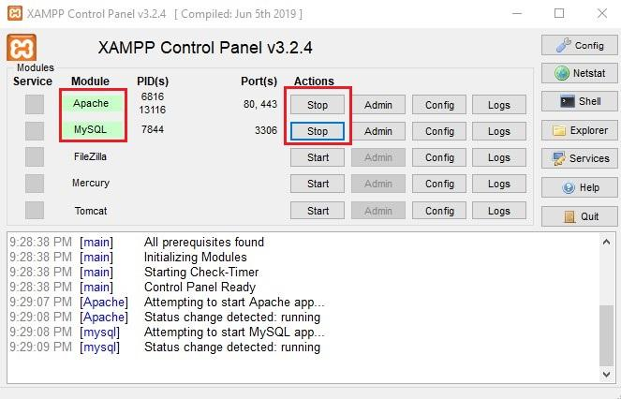
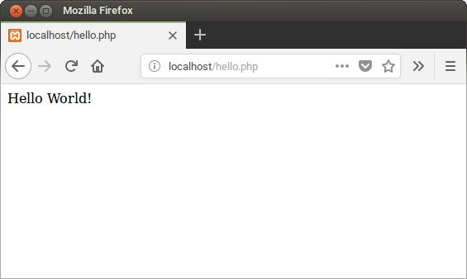
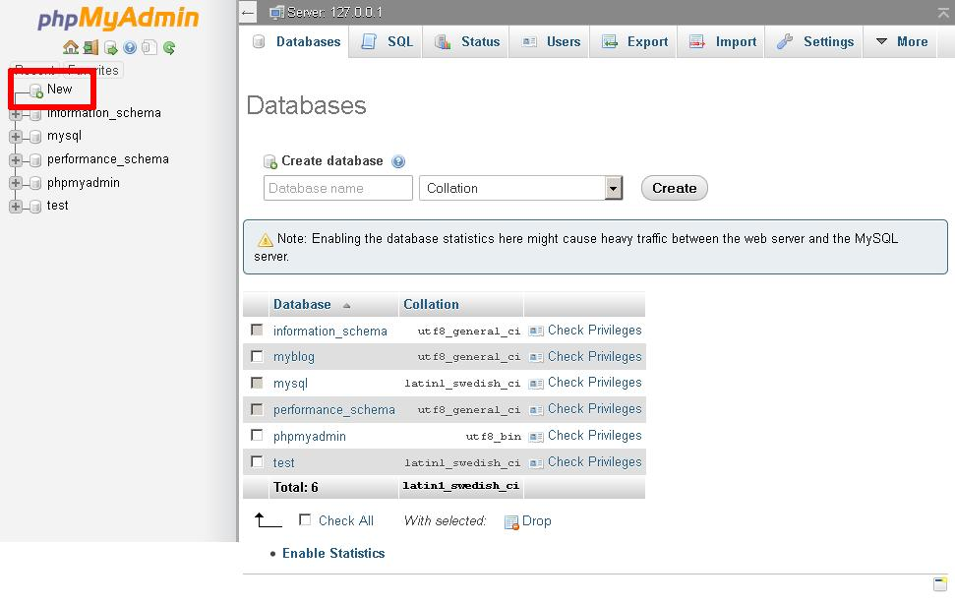

1. Components of XAMPP


Apache
Web server
Apache receives browser requests and delivers web pages. It runs PHP scripts through PHP integration.


MariaDB / MySQL
Database server
Stores and manages data such as student records, users, posts, and website content.


PHP
Server-side programming language
Processes PHP code to generate dynamic web pages.


Perl
Programming language
Included in the XAMPP package for scripting and development tasks.
Other useful tools included in XAMPP:
- phpMyAdmin: A browser-based tool for managing databases.
- XAMPP Control Panel: Used to start and stop Apache and MySQL/MariaDB.
- FileZilla FTP Server: Included in some XAMPP distributions; useful for FTP practice.
- Tomcat: Available as an optional component in some XAMPP packages.

2. How XAMPP Server Works
Web Browser
Chrome / Edge / Firefox
Apache Web Server
Receives HTTP requests
PHP
Processes server-side code
MariaDB / MySQL
Stores and retrieves data when needed
HTML response displayed in the browser

Example
Suppose you create a PHP file:
PHP
<?php
echo "Hello, XAMPP Server!";
?>
Save it as index.php inside your website folder, then open:
http://localhost/index.php
Apache runs the PHP script and sends the result to your browser:
Hello, XAMPP Server!

3. XAMPP Control Panel
The XAMPP Control Panel is the main interface for controlling local services.
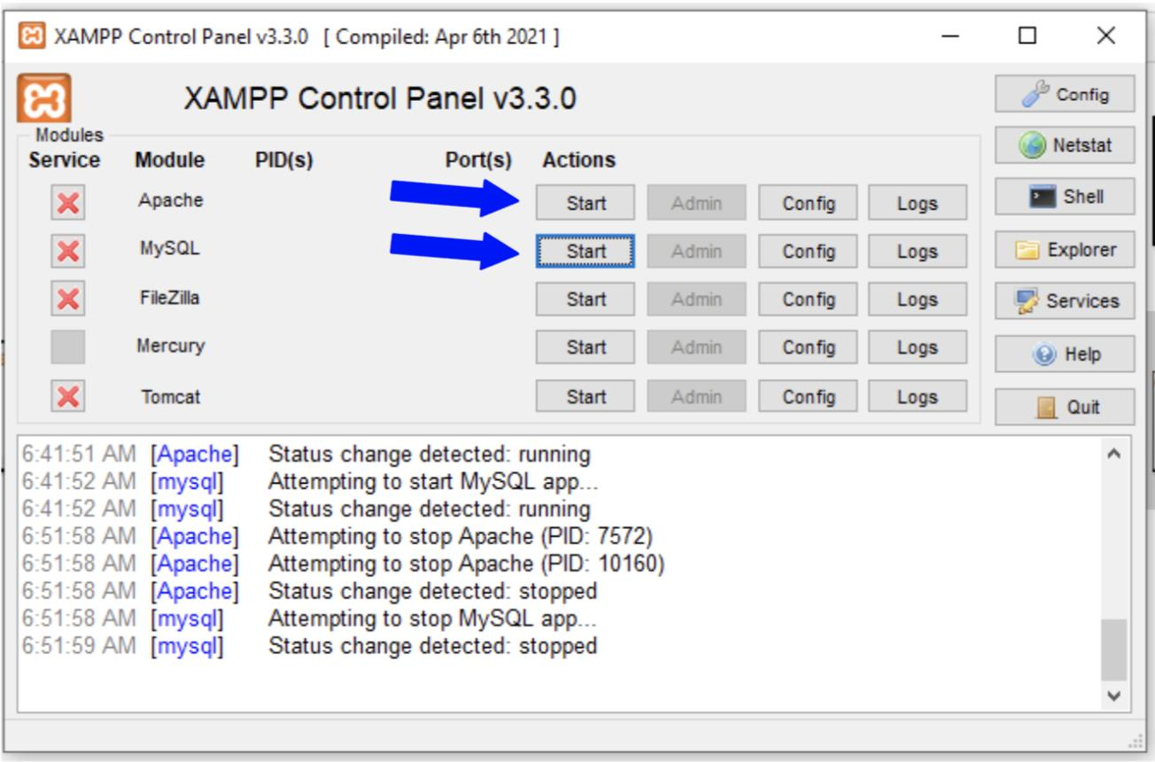
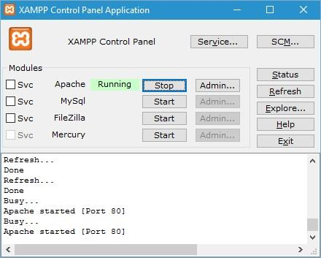
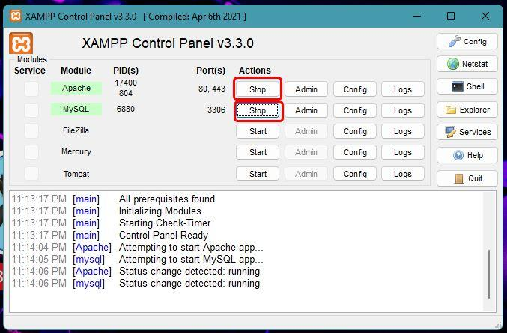
|
Service
|
Purpose
|
| --- | --- |
|
Apache
|
Runs PHP websites and serves web pages
|
|
MySQL / MariaDB
|
Runs the database server
|
|
Start
|
Starts a service
|
|
Stop
|
Stops a service
|
|
Admin
|
Opens the service's management page
|
|
Logs
|
Shows service error and activity logs
|
When Apache and MySQL are running, the Control Panel normally shows them as active.

4. Default Server Information
|
Item
|
Default value
|
| --- | --- |
|
Localhost
|
http://localhost/
|
|
Apache HTTP port
|
80
|
|
Apache HTTPS port
|
443
|
|
MySQL / MariaDB port
|
3306
|
|
Website root folder
|
C:\xampp\htdocs\
|
|
Database management
|
phpMyAdmin
|
|
phpMyAdmin URL
|
http://localhost/phpmyadmin/
|
Note: These are common defaults for XAMPP on Windows. Ports and folder locations can be changed during installation or configuration.

5. How to Run a PHP Website in XAMPP
Step 1
Install XAMPP
Download and install XAMPP on your computer.
Step 2
Start Apache
Open XAMPP Control Panel and click Start beside Apache.
Step 3
Create a project folder
Create a folder inside:
C:\xampp\htdocs\mywebsite
Step 4
Create an index.php file
PHP
<?php
echo "Welcome to my website";
?>
Step 5
Open the website
Visit:
http://localhost/mywebsite/

6. PHP Website vs HTML Website
|
Feature
|
HTML
|
PHP
|
| --- | --- | --- |
|
File extension
|
.html
|
.php
|
|
Needs Apache for local XAMPP testing
|
Not necessarily
|
Yes
|
|
Server-side processing
|
No
|
Yes
|
|
Database connection
|
Not directly
|
Yes, using PHP
|
|
Dynamic content
|
Limited to client-side scripts
|
Can generate dynamic HTML
|
Example of a PHP database connection:
PHP
<?php
$conn = new mysqli("localhost", "root", "", "school");

if ($conn->connect_error) {
die("Connection failed");
}

echo "Database connected successfully";
?>
This example connects PHP to a database named school using the common local development username root. A blank password is a common XAMPP default, but it may differ on your installation.

7. Advantages of XAMPP
- Free to use.
- Easy to install and configure.
- Runs websites locally without internet hosting.
- Supports PHP and database development.
- Useful for WordPress development.
- Helps students practice web development.
- Allows testing before publishing a website online.

8. Important Terms
Localhost: Your own computer acting as a web server.
Server: Software that receives requests and provides responses.
Apache: The web server included in XAMPP.
Database: An organized collection of information.
PHP: A server-side language used to build dynamic websites.
phpMyAdmin: A tool for managing MySQL/MariaDB databases through a browser.
htdocs: The main folder where Apache looks for website files in a standard XAMPP installation.

Quick student self-check
Which XAMPP component processes PHP requests?
Apache
MySQL / MariaDB
phpMyAdmin
FileZilla

